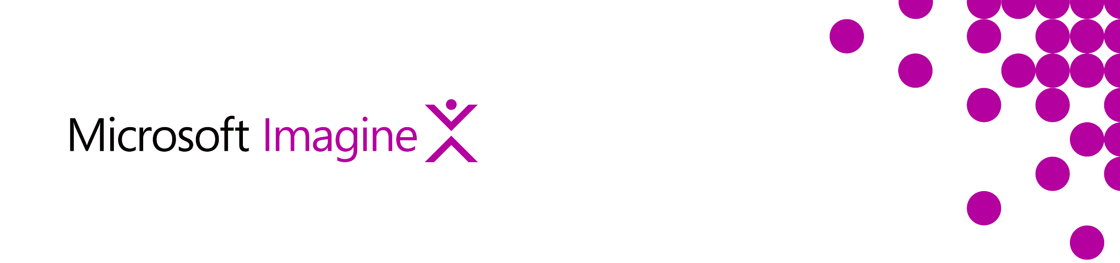**Mobile Development**

Optimization of the performance and user experience of mobile apps has increased the demand for full-featured, server-side mobile app solutions. These solutions include mobile-accessible cloud storage, authentication, and push notifications. Azure Mobile Apps is a service suite providing baseline features like SQL Databases, mobile push notifications, brand-name authentication via Facebook and Twitter for consumer apps, and Azure Active Directory(AAD) for enterprise apps. Access to these features is condensed into the Azure Mobile SDK, an API used by mobile developers to access the Azure cloud feature set, including local/remote data sync. Serverless nanoservices that instantiate on-demand are becoming more common as mobile back-ends and Azure Functions provide these services that are easily implemented in mobile dev architectures.

**Mobile App Server-Side Solutions**

Azure Mobile Apps is a suite of services that provide back-end support to native and cross-platform mobile apps. It offers features important to mobile app developers including:

* Cloud Storage
* Offline Data Sync
* Authentication
* Push Notifications

Developers can take advantage of Azure Mobile Apps using the Azure SDK for native iOS, Android, Windows, or cross-platform Cordova or Xamarin apps.

[Learn More](https://docs.microsoft.com/en-us/azure/app-service-mobile/app-service-mobile-value-prop)

[Get Started](https://docs.microsoft.com/en-us/azure/app-service-mobile/app-service-mobile-xamarin-forms-get-started-offline-data)

**Cloud Storage**

Mobile apps need server-side virtual storage with cloud databases and tables that can be instantiated and destroyed on demand. Azure SQL Databases provide cloud storage that is easy to set up and low maintenance, requiring no administration of physical disk, partitions, or logging. They have automatic backups and software updates, and automatic tuning and threat detection.

A feature called Easy Tables provides a rapid app development approach by automatically creating columns in a table as data is inserted. The table automatically adds columns to itself based upon data inserted into the table using the Azure SDK.

The Azure SDK provides a straightforward way to create SQL Database table references from within a mobile app and conduct CRUD transactions. Azure SDK meets your mobile app’s data access needs by querying, filtering, sorting, and syncing data to a local database, such as SQLite. Use the Azure SDK in your mobile app or server-side code to obtain references to your app’s Azure SQL Database URL and tables. Execute CRUD transactions against your tables, and filter and sort by row, column, and id. Access to Azure tables can also be achieved using Visual Studio Mobile Center (VSMC).

[Learn More](https://docs.microsoft.com/en-us/azure/sql-database/)

[Get Started](https://docs.microsoft.com/en-us/azure/sql-database/sql-database-get-started-portal)

**Offline Data Sync**

Sync data local-to-cloud using a SQLite database, an Azure SQL Database, and the Azure SDK. In your mobile app, use a local SQLite database and bind it to your Azure cloud data source. All writes go to the local SQLite database. Sync the databases with push and pull methods. Data is sent to the Azure SQL Database only when explicitly synced using the SDK’s async methods. Remote data sync from multiple client apps raises the risk of conflicts. Handle sync errors using a try/catch exception handler or by implementing a sync handler interface.

[Learn More](https://docs.microsoft.com/en-us/azure/app-service-mobile/app-service-mobile-offline-data-sync)

[Get Started](https://docs.microsoft.com/en-us/azure/app-service-mobile/app-service-mobile-xamarin-forms-get-started-offline-data)

**Authentication**

Azure Authentication integrates with Azure Active Directory (AD) and third parties such as Facebook, Google, MS Account, and Twitter.

Using standard OAuth workflow, the mobile app retrieves an authentication token from an authentication provider to access a protected service. This token is used to create an identity for the mobile app which is passed to the target mobile service. The acceptance of this identity finalizes the authentication. The mobile service then executes the desired function and returns requested values (if any) to the calling mobile app.

[Learn More](https://docs.microsoft.com/en-us/azure/app-service-mobile/app-service-mobile-auth)

[Get Started](https://docs.microsoft.com/en-us/azure/app-service-mobile/app-service-mobile-how-to-configure-twitter-authentication)

**Push Notifications**

Due to the secure and proprietary nature of mobile push notifications, OS providers each utilize their own Push Notification Service (PNS). Cross-platform development must integrate with two or more services which can become unwieldy. Azure Notification Hubs provides a single notification hub for server-side notification generators. Provide Azure Notification Hubs with access to the platform-specific PNS then push messages to the hub using platform-specific methods in your mobile app, as specified in the Azure SDK.

Use Azure Notifications Hubs to broadcast notifications by user, device, or platform, in real-time or scheduled. The hub service scales to millions of devices and supports all major push platforms including iOS, Android, Windows, Kindle, and Baidu.

[Learn More](https://docs.microsoft.com/en-us/azure/notification-hubs/notification-hubs-push-notification-overview)

[Get Started](https://docs.microsoft.com/en-us/azure/notification-hubs/notification-hubs-android-push-notification-google-fcm-get-started)

**Mobile App Services**

Containers like Docker can be created and populated with services for consumption by mobile apps. Azure Mobile Apps is a full-featured service suite custom-made for mobile development, providing containers, built-in and from-scratch services, access to data sources, maintained and administered maintenance-free on the Azure platform.

[Learn More](https://docs.microsoft.com/en-us/azure/app-service-mobile/app-service-mobile-value-prop)

[Get Started](https://docs.microsoft.com/en-us/azure/app-service-mobile/app-service-mobile-ios-get-started)

**Serverless Mobile Back Ends**

Azure Functions are small, event-driven pieces of code hosted inside on-demand, self-administering containers. Azure Functions provide a trigger, input, and output model. The most basic trigger or event, from a mobile app is an HTTP call which can pass and return JSON. Functions can have many other triggers besides HTTP calls. Functions can be driven by data events, such as the addition of a new row to a table or a new blob to a container. Functions are driven by actions within a queue, or on a schedule, or by a GitHub webhook request.

The Azure Function’s Input and Output elements can consist of various server-side resources such as table and blob storage. Functions can be coded in C#, F#, or JavaScript and are cost-effective as they only consume billable resources while running.

[Learn More](https://docs.microsoft.com/en-us/azure/azure-functions/functions-bindings-mobile-apps)

[Get Started](https://docs.microsoft.com/en-us/azure/azure-functions/functions-create-first-azure-function)